Project Questions

1.What is the total amount each customer spent on zomato?

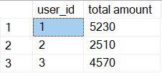

2. How many days has each customer visited zomato?

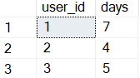

3. What was the first product purchased by each customer

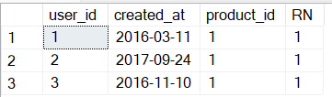

4. What is the most purchased item on the menu and how many times was it purchased by all customers?

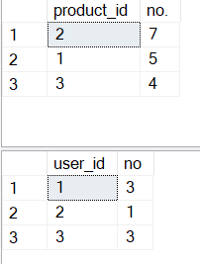

5. Which item was the most popular for each customer

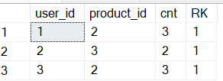

6. Which item was purchased first by the customer after they became a gold member?

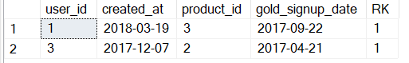

7.Which item was purchased just before the customer become a member?

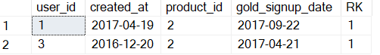

8. what is the total orders and amount spend for each member before they become a member?

